Installing the FIRSTWA Recorder Application

# Prerequisites

* Microsoft .NET Framework 4.6.1
* Administration rights

# Steps to install

1. Create 4 registry subkeys:
   1. Open Start Menu
   2. Type “regedit” in search. Open “Registry Editor”

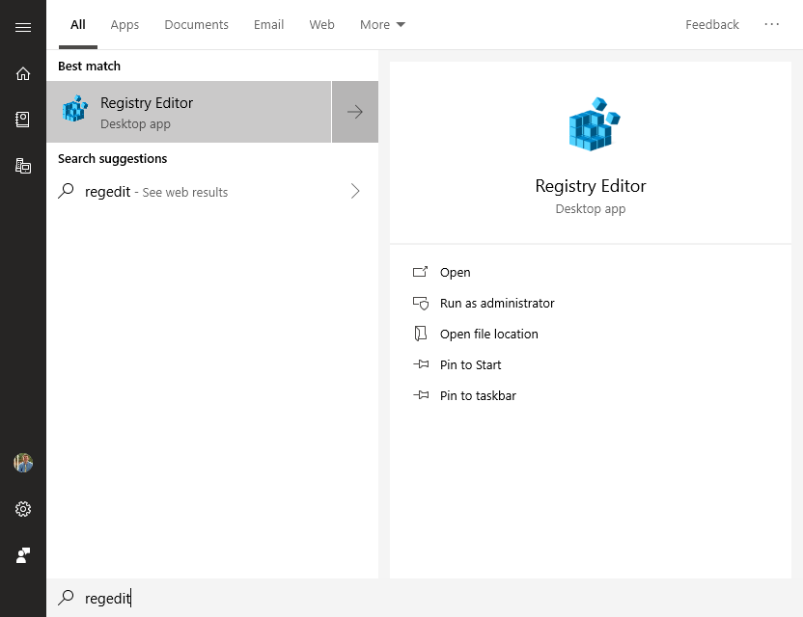

* 1. Navigate to: Computer\HKEY_CURRENT_USER\Software
  2. Create a new key, “FIRSTWA”, at: Computer\HKEY_CURRENT_USER\Software\FIRSTWA

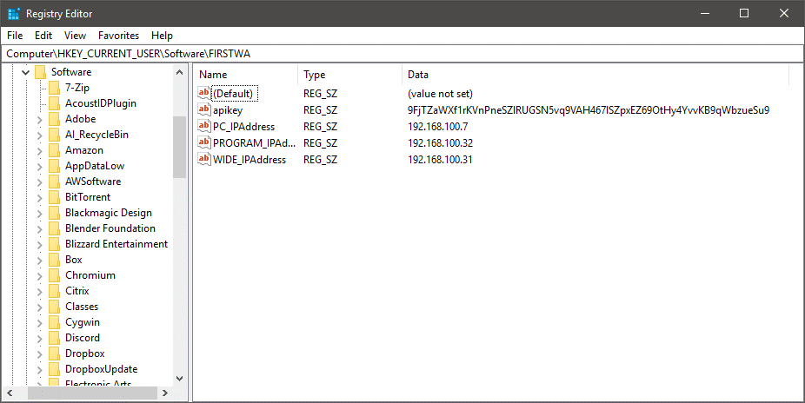

* 1. Create 4 subkeys (capitalization matters!):
     1. apikey
        1. Value = 9FjTZaWXf1rKVnPneSZlRUGSN5vq9VAH467lSZpxEZ69OtHy4YvvKB9qWbzueSu9

RED TRUCK:

* + 1. PC_IPAddress
       1. Value = 192.168.100.7
    2. PROGRAM_IPAddress
       1. Value = 192.168.100.32
    3. WIDE_IPAddress
       1. Value = 192.168.100.31

BLUE TRUCK:

1. PC_IPAddress
   * + 1. Value = 192.168.100.70
2. PROGRAM_IPAddress
   * + 1. Value = 192.168.100.35
3. WIDE_IPAddress
   * + 1. Value = 192.168.100.34
4. Download installer ZIP file from the OneDrive
   1. The ZIP file is under “FIRSTWA Recording App” and is called, “FIRSTWA Recording App.zip”
   2. Unzip the folder (“Release”) and place it in Documents
5. Copy to install location
   1. Open Windows Explorer
   2. Navigate to: C:\Program Files (x86)
   3. Create a folder: “FIRSTWA”
   4. Copy the “Release” folder, from step 2, to this folder

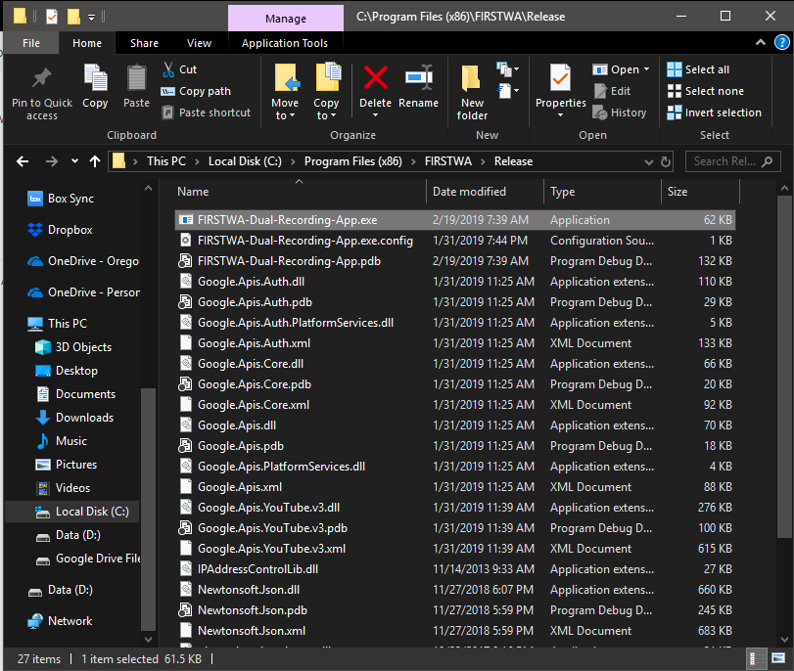

1. Create shortcut in start menu:
   1. Open Windows Explorer
   2. Navigate to the installation folder with
   3. Navigate to: shell:programs
   4. Create a folder, “FIRSTWA”
   5. Right-Click and create a new shortcut

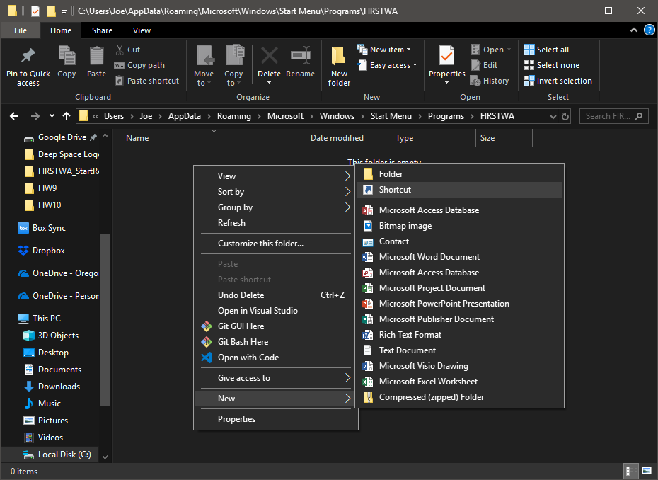

* 1. In the Create Shortcut window, navigate to C:\Program Files (x86)\FIRSTWA, and select “FIRSTWA-Dual-Recording-App.exe”

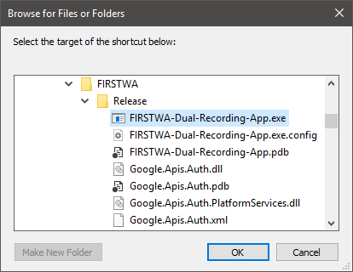

* 1. Click “Next”
  2. For the name of the shortcut: “FIRSTWA Recorder”

# How to use the app

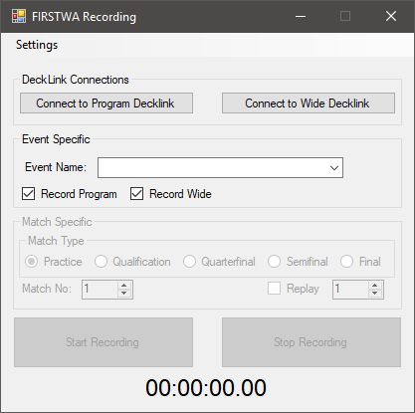

## Checklist

* Go to Settings>Recording, and confirm the IP addresses are correct:

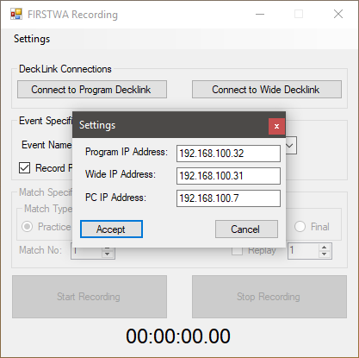

* Confirm that the two DeckLink recorders, the TV switcher, and the main PC are all turned on and connected to the network
* Confirm that Case 59 is connected to the internet and has access to thebluealliance.com

## Basic Steps

1. Click the two buttons, “Connect to Program Decklink” and “Connect to Wide Decklink”. Some of the buttons will become enabled.
2. Choose the event that you’re at using the dropdown box.

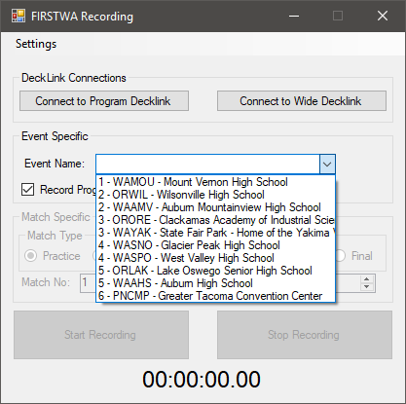

1. Confirm that both checkboxes, “Record Program” and “Record Wide” are both checked
   1. These checkboxes allow you to record from a single stream **\*\*UNTESTED\*\***
2. Choose a match type using the radio buttons
3. Choose a match number
   1. You can also choose to select the “Replay” checkbox and note what number this is **\*\*UNTESTED\*\***
4. When the match starts, click “Start Recording”. The timer at the bottom will start counting up and the recording lights, on the DeckLinks, will be Red
5. When the match is over, click “Stop Recording”.
6. The program will automatically copy the recorded videos to the following folder structures:
   1. Program Recording: V:\FTP_Folder\2019\<event>\PROGRAM
   2. Wide Recording: V:\FTP_Folder\2019\<event>\WIDE
   3. This process will take a few minutes to complete.
7. The match number will automatically increment, but the user is responsible for confirming the match number before starting the recording.